**IMPLEMENTATION OF GPS MODULE**

**To implement the Neo-6 GPS module with an Arduino Uno in a toy model for GPS tracking, follow these steps to handle wiring, coding, and placing the module correctly for optimal GPS signal reception.**

**1. Wiring and Connections**

The Neo-6 GPS module communicates via UART (TX/RX) and needs to be connected to the Arduino's UART pins or using software serial.

**Neo-6 GPS Pinout:**

1. VCC: Power supply (3.3V - 5V, typically 5V)
2. GND: Ground
3. TX: Transmit (Data from GPS to Arduino)
4. RX: Receive (Not needed in most cases)

**Arduino Uno Pinout:**

1. 5V: Connect to Neo-6 GPS VCC (5V supply)
2. GND: Connect to Neo-6 GPS GND
3. Pin 4 (Software Serial RX): Receive data from Neo-6 GPS TX

**2. Software and Code**

You’ll use the TinyGPS++ library to decode and read data from the GPS module. Here's how to set it up in Arduino IDE.

**Arduino Code Example:**

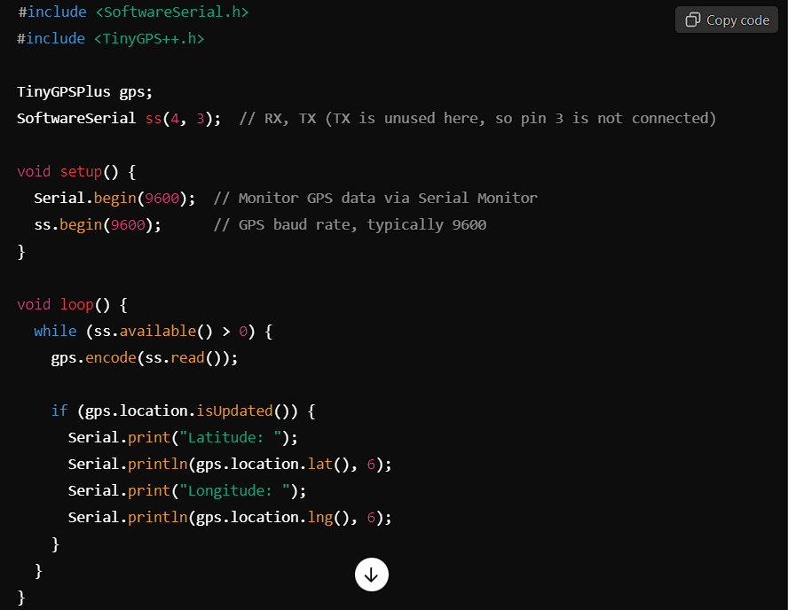

In the above code:

1. The GPS data is read via SoftwareSerial from the Neo-6 module's TX pin.
2. TinyGPS++ decodes the GPS signals and provides latitude/longitude data

**3. Placement in the Toy Model**

The Neo-6 GPS module requires a clear line of sight to the sky to receive GPS signals, so its placement in the toy model is critical. Follow these guidelines for optimal performance:

**Top or Outer Surface**: Place the GPS module on the top or outer part of the toy, ideally in a place that is open to the sky.

**Away from Metal Components**: Metal components can block or interfere with GPS signals, so avoid placing the GPS module near metal parts.

**Orientation**: The side of the GPS module with the antenna (usually the flat side with a small patch antenna) should face upwards.

**Protected but Accessible**: Protect the module from damage by mounting it securely, but ensure it’s not enclosed in a fully metallic or thick plastic casing that can block signals.

**3.Power Supply**

Make sure the power supply for both the Arduino Uno and the Neo-6 GPS is stable. The Neo-6 GPS typically works at 5V, and the Arduino Uno provides a 5V output. However, if your toy uses a battery system, ensure that it can provide sufficient power.

**Summary**

Wiring: Connect Neo-6 TX to Arduino RX (SoftwareSerial), power the module via Arduino's 5V and GND.

Code: Use the TinyGPS++ library to decode and print GPS data.

Placement: Place the GPS module on the toy's top or outer surface for a clear sky view.

Power: Ensure stable power, and consider using a suitable battery for mobile toy applications.

**EXTRA**

**Prototyping and Testing**: If you’re still experimenting with the connections and want flexibility to change wiring easily, a breadboard can be used with neo 6 gps module to help you avoid soldering.

**REFERENCE VIDEO FOR IMPLEMENTATION :**

1. <https://youtu.be/yKtngUPFJbU?si=StjDFgfnDX6sk3Ve>
2. <https://youtu.be/ViZT5w7tPqI?si=nysaMJtmRlUKvm8B>